Lucky thumb motorcycle club
Fence or T-Shirt Sponsorship Program
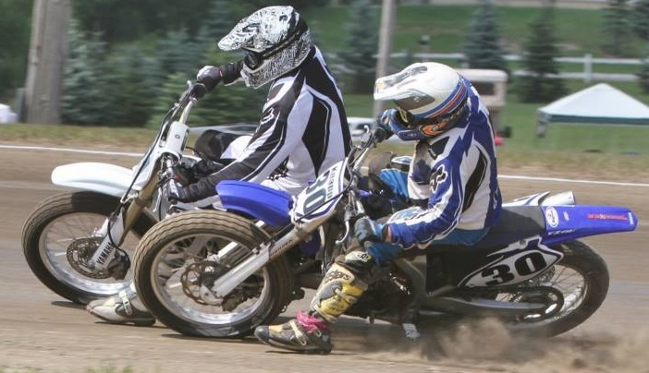
Option #1 Option #2 Option #3
3”
Your Logo or Ad on back of our 2023 Season T-Shirts , on our Web Site Sponsor Page. Deadline for t-shirt ads is April 30th.
$100
PURCHASE A SIGN ALONG WITH THE TSHIRT AD WE WILL DISCOUNT THE TSHIRT AD TO $80

3’x4’ Sign on our Fence with your Logo
$200.00
Then a
Maintenance fee
$100 per year

3’x8’ Sign on our Fence with your Logo

$300.00
Then a
Maintenance fee
$100 per year

Option #4
If you would like to sponsor a class with your name on the trophy as a class sponsor, it is $60 per class for normal summer events, or $200 per class for State Championship events per day.

Attach your logo, artwork, or ad here and send payment to: Lucky Thumb Motorcycle Club, P.O. Box 21, Snover, MI 48472 or Questions call Raymie Ellis at 810-404-2895 or email to raymie2895@gmail.com
NAME_____________________________________________OPTION(S) #____________
BUSINESS NAME__________________________________________________________
ADDRESS________________________________________________________________
CITY_____________________________________STATE_____________ZIP___________
PHONE_____________________________ EMAIL_______________________________
PAID WITH: CASH_______CHECK________
Thank you for your continued support of our racing programs. We appreciate your support!!

